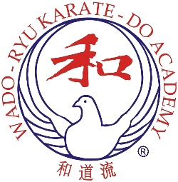
Summer Course Report: July 2026
The Annual Summer Course took place from Saturday 25th to Wednesday 29th July in Weston-super-Mare, instruction led by Arthur Meek Sensei assisted by Peter Hill Sensei and special guests from Japan: Tanemura Sensei, Kawano Sensei and Hijikata Sensei.

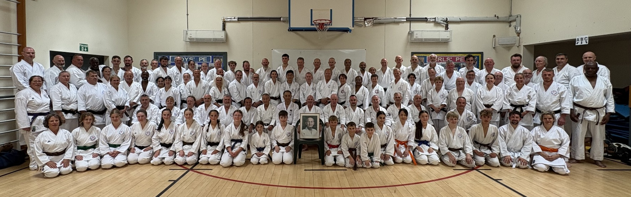
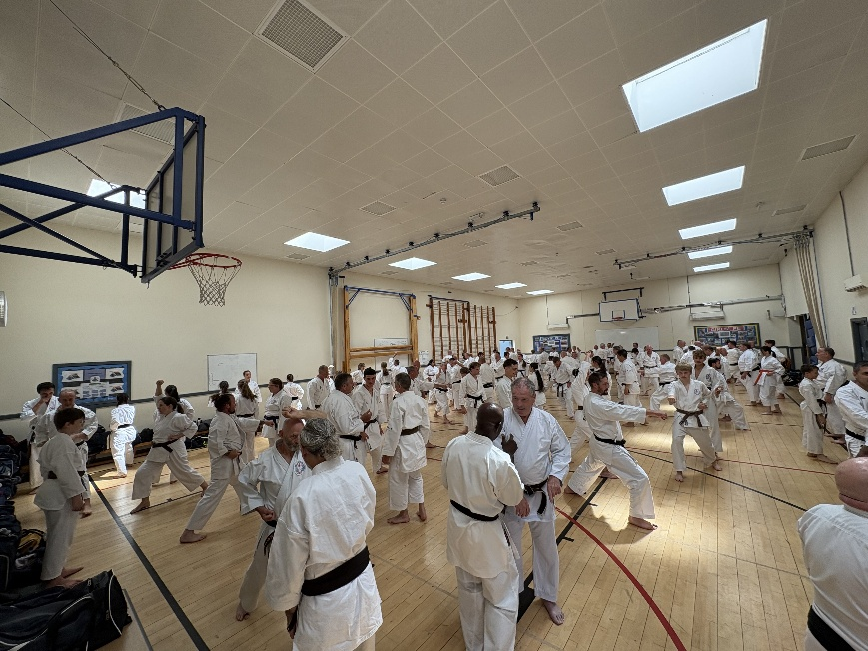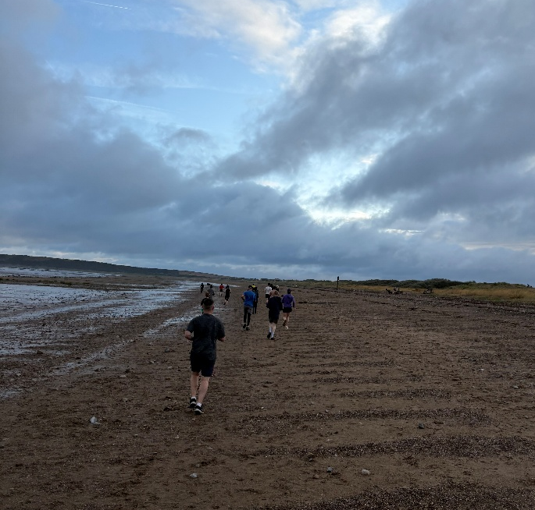
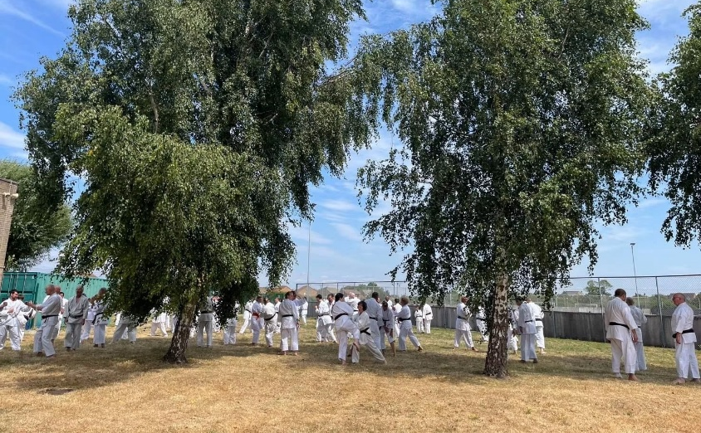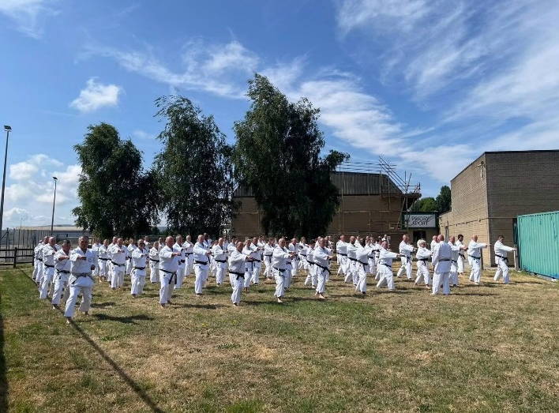
Attendees: Saturday 100, Sunday 103, Monday 79, Tuesday 74, Wednesday 64

Dan Grade Passes:
1st Dan Stefan Miller, Simon Sheridan, Henry Prole, Nikole Da Silva, Enyuan Wu
2nd Dan Anne Schiettecatte

