
Jiu-Jitsu/Idori incorporated Wado Ryu
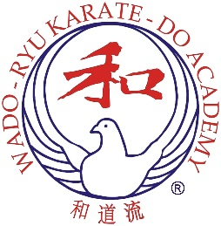
INSTRUCTOR’S

COURSE
Sunday 8th November 2026
12.00noon – 2.30pm

Budo Juku Dojo
Eastover Youth Centre, All Saints Terrace
Bridgwater, Somerset, TA6 5JQ

Subsidised Course cost:
£15.00
The Acting Chief Instructor of the Wado-Ryu Karate-Do Academy, Arthur Meek 8th Dan Renshi would like to invite 1st Kyu and Dan Grade members to an Academy Instructors’ Course.

The aim of these courses is to maintain the very high standards of Wado-Ryu Karate that Academy members achieve.

This course will be using advance registration, with 30 spaces available on a first-come first-served basis. Please kindly complete the application form and email to info@wadoacademy.com with payment details.
The application form must be received via email by Wednesday 4th November.

APPLICATION FORM

Name write above line Age (if under 16 yrs) write above line
Address write above line
Post Code write above line Tel No write above line E-Mail write above line
Wado Academy Membership No (write above line) Expiry Date (write above line) Grade (write above line)

Name of your Instructor write above line Club write above line

PAYMENT OPTIONS (Please tick the appropriate box):

☐ | IN ADVANCE: Payment made by Bank Transfer to:  Wado-Ryu Karate-Do Academy Sort Code: 30-98-97 Account No: 78489663

☐ | ON THE DAY: by Cash (correct amount please)

Office Address: Wado Academy, PO Box 48, Torrington, North Devon, EX38 9AU Email: info@wadoacademy.com

